Tutorial 6 – Manual Test Execution
Screenshot Report
Field | Details
Website / Tool | DemoBlaze
URL | https://www.demoblaze.com
Module | Shopping workflow
Student Task | Test the complete shopping workflow with 12 test cases and prepare the execution summary.
Test Cases | Same TC IDs as the test case sheet: TC01 to TC12
Tester Name | Tester: Kothari Mann Jitendrakumar
Enrollment No | 2504030100433
Environment | Windows 10/11, Google Chrome (latest), internet connection

Test Case Execution

TC01 – Verify the website opens
TC ID | TC01
Test Case | Verify the website opens
Test Data | URL: https://www.demoblaze.com
Expected Result | Home page loads with the product categories and product list
Actual Result | Home page loaded
Status | PASS
Screenshot | 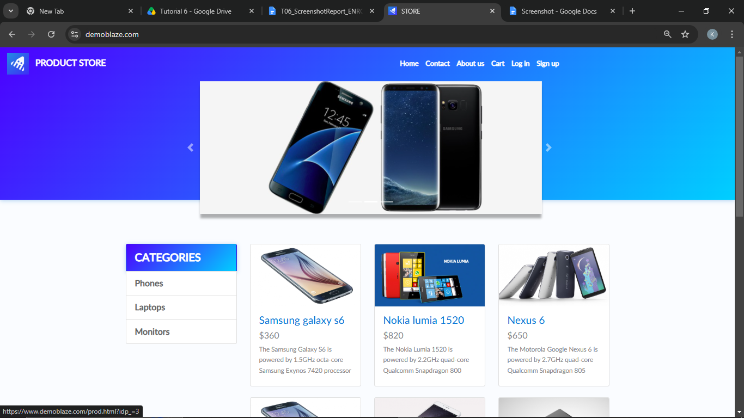
Defect ID | N/A

TC02 – Verify a product category can be selected
TC ID | TC02
Test Case | Verify a product category can be selected
Test Data | Category: Laptops
Expected Result | Laptop products are displayed
Actual Result | Laptops displayed
Status | PASS
Screenshot | 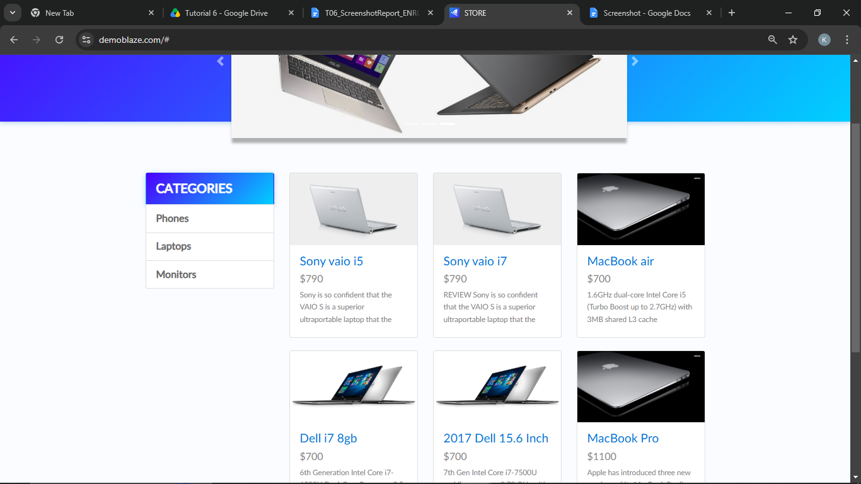
Defect ID | N/A

TC03 – Verify a product can be selected
TC ID | TC03
Test Case | Verify a product can be selected
Test Data | Product: Macbook air
Expected Result | Product page opens
Actual Result | Product page opened
Status | PASS
Screenshot | 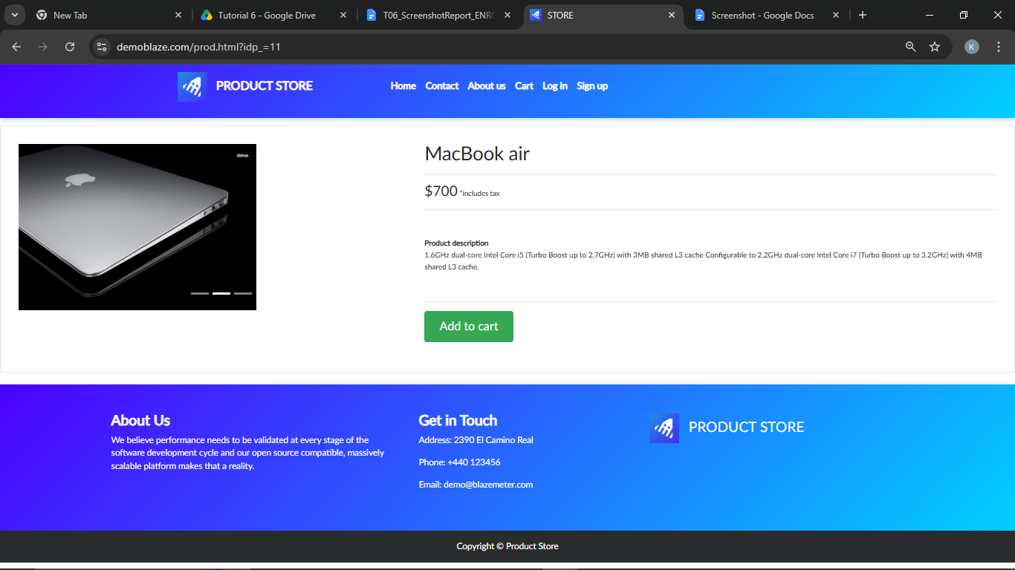
Defect ID | N/A

TC04 – Verify the product details
TC ID | TC04
Test Case | Verify the product details
Test Data | Product: Mackbook air
Expected Result | Product name, price, description and Add to cart button are displayed
Actual Result | Details displayed
Status | PASS
Screenshot
Defect ID | N/A

TC05 – Verify a product can be added to the cart
TC ID | TC05
Test Case | Verify a product can be added to the cart
Test Data | Product: Mackbook Air
Expected Result | Alert 'Product added' is displayed
Actual Result | Alert displayed
Status | PASS
Screenshot | 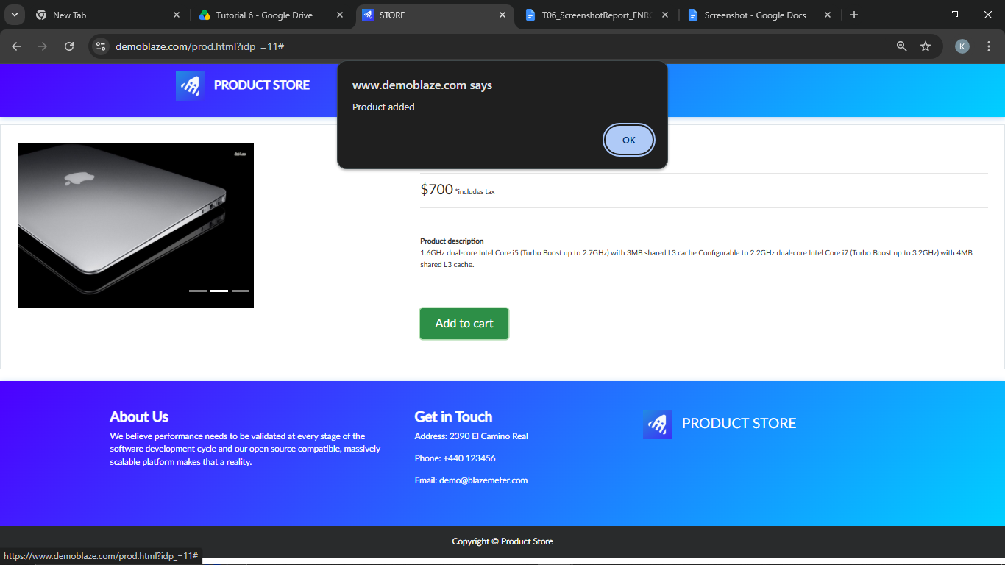
Defect ID | N/A

TC06 – Verify the cart page opens
TC ID | TC06
Test Case | Verify the cart page opens
Test Data | Product list of add to cart
Expected Result | Cart page opens
Actual Result | Cart page opened
Status | PASS
Screenshot | 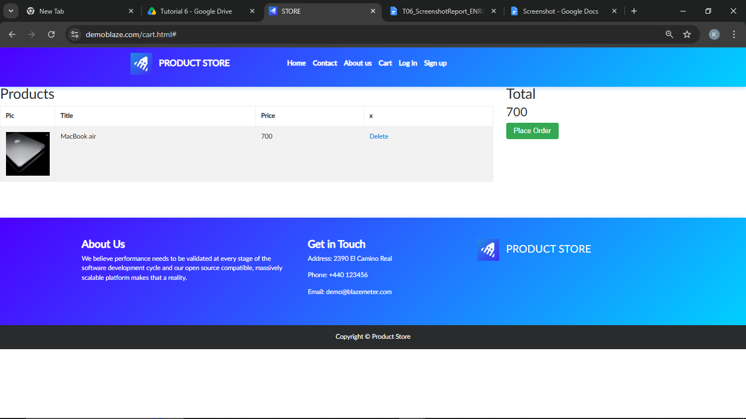
Defect ID | N/A

TC07 – Verify product and total in the cart
TC ID | TC07
Test Case | Verify product and total in the cart
Test Data | Product: Mackbook Air
Expected Result | Product and price are listed and Total equals the price
Actual Result | Product and total correct
Status | PASS
Screenshot | 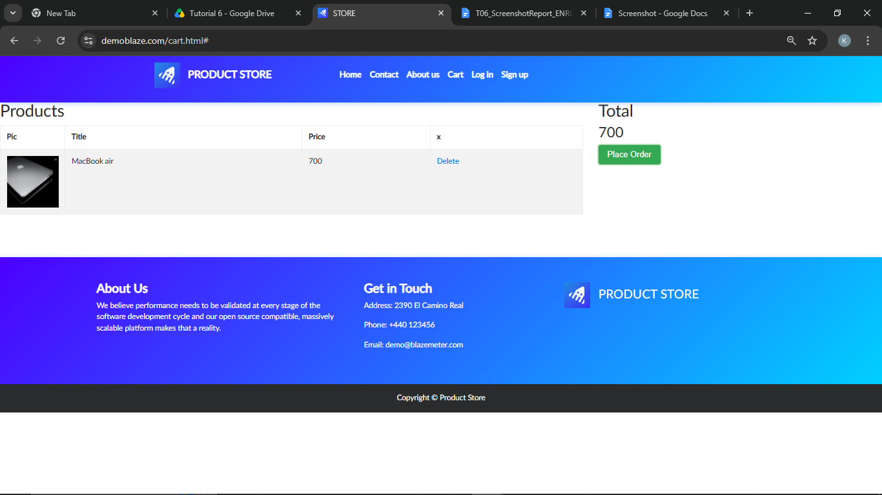
Defect ID | N/A

TC08 – Verify the Place Order form opens
TC ID | TC08
Test Case | Verify the Place Order form opens
Test Data | -
Expected Result | Place Order form opens with Name, Country, City, Credit card, Month and Year fields
Actual Result | Form opened
Status | PASS
Screenshot | 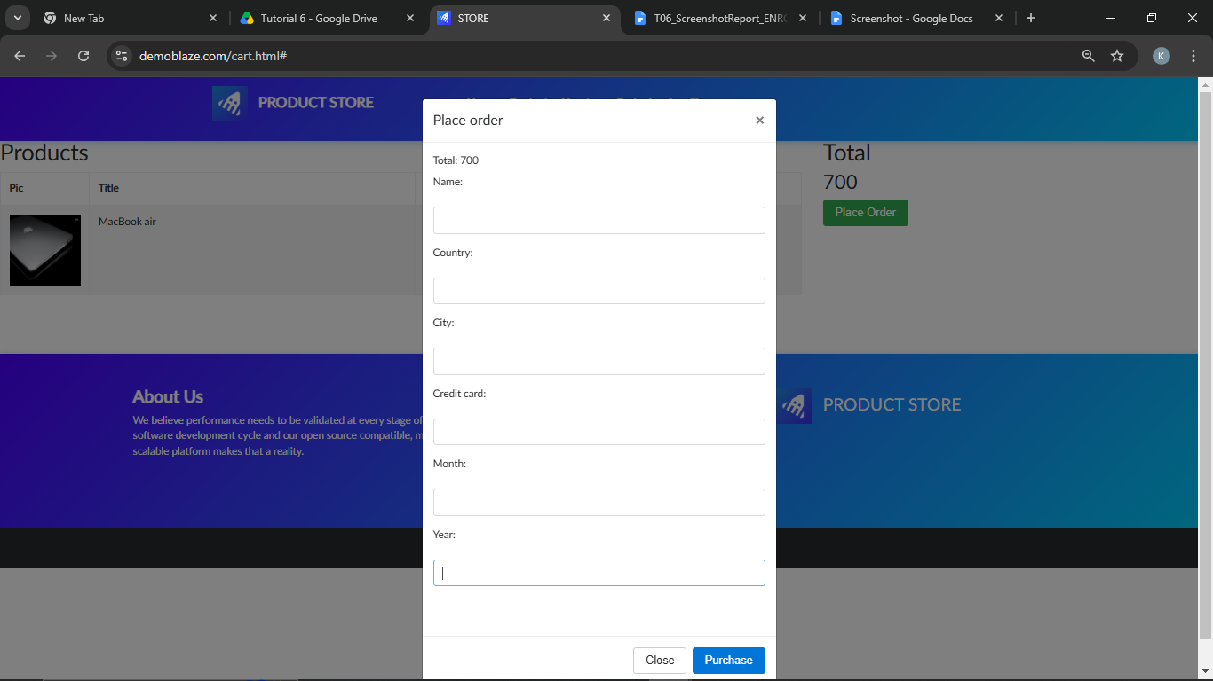
Defect ID | N/A

TC09 – Verify order with blank customer details
TC ID | TC09
Test Case | Verify order with blank customer details
Test Data | All fields blank
Expected Result | Alert 'Please fill out Name and Creditcard.' is displayed
Actual Result | Alert displayed
Status | PASS
Screenshot | 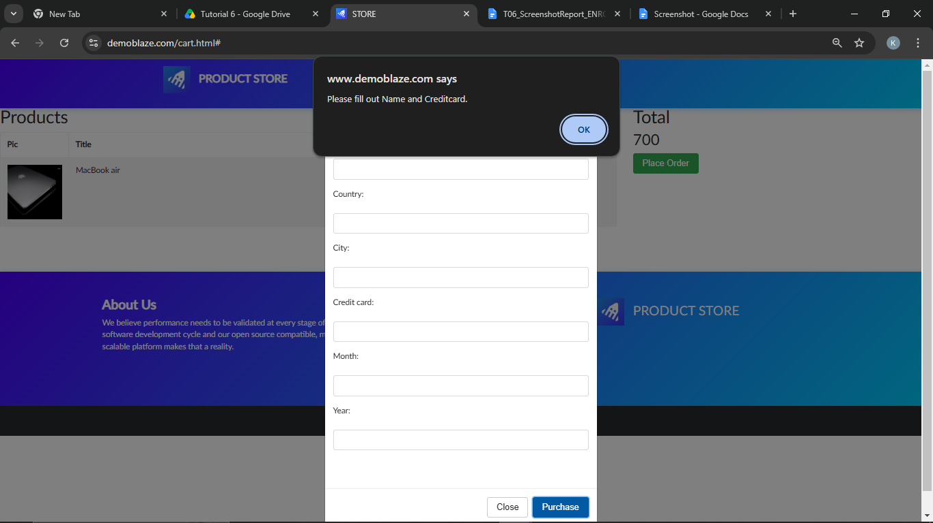
Defect ID | N/A

TC10 – Verify customer details can be entered
TC ID | TC10
Test Case | Verify customer details can be entered
Test Data | Name: Test User; Country: India; City: Ahmedabad; Card: 4111111111111111; Month: 12; Year: 2028
Expected Result | All fields accept the entered values
Actual Result | Values accepted
Status | PASS
Screenshot | 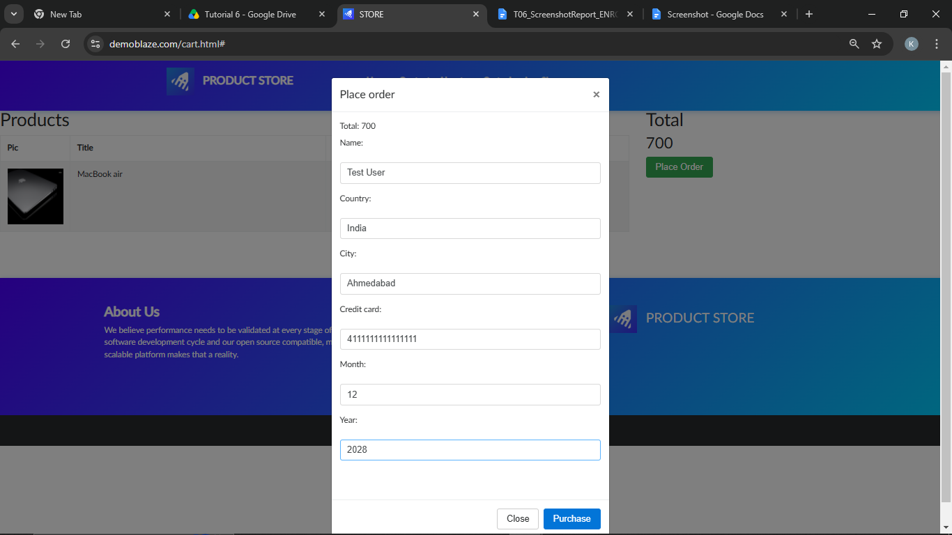
Defect ID | N/A

TC11 – Verify the order can be submitted
TC ID | TC11
Test Case | Verify the order can be submitted
Test Data | Details from TC10
Expected Result | 'Thank you for your purchase!' confirmation with order Id and Amount is displayed
Actual Result | Confirmation displayed
Status | PASS
Screenshot | 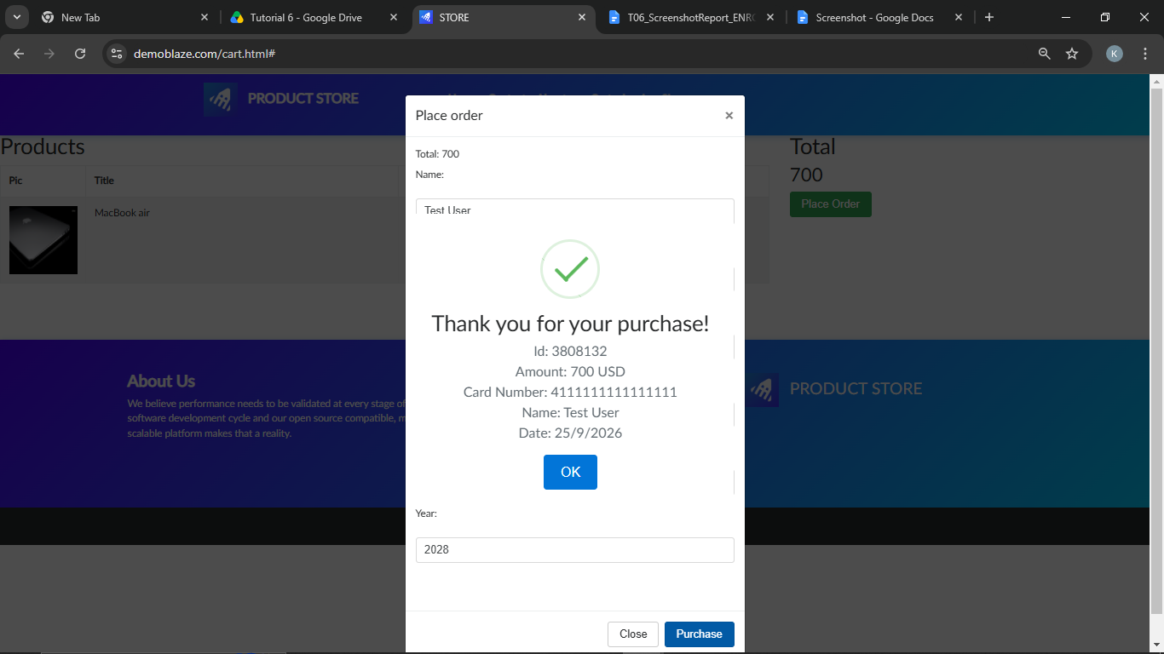
Defect ID | N/A

TC12 – Verify the order confirmation closes
TC ID | TC12
Test Case | Verify the order confirmation closes
Test Data | -
Expected Result | User returns to the home page
Actual Result | Returned to home page
Status | PASS
Screenshot | 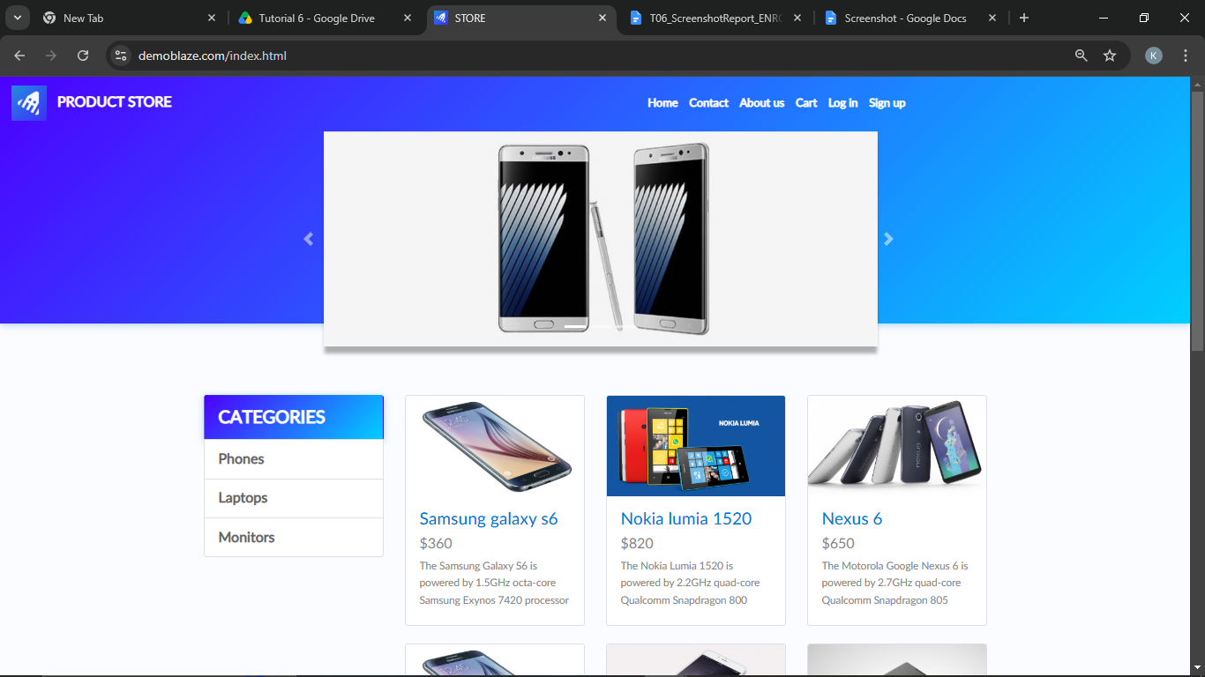
Defect ID | N/A

Test Execution Summary
Metric | Value
Total Test Cases | 12
Passed | 12
Failed | 0
Blocked | 0
Not executed yet (fill after running) | 0
Pass % | 100.0%

